DX Office Hours: Data retention and deletion plan.

1. **Data Description:**

The field ‘ISV name’ is retained in table storage, and is only linked to the Technical Evangelist that ran the session and data on the time and date of the session.

As below, to inform the user of their session, we need to transfer their name and email to the TE’s Office 365 Outlook account to send the email with the calendar appointment, this may be retained in the sending TE’s calendar and sent items (This transfer is executed by using Azure Service Bus and Microsoft Flow).

1. **Timetables:**

ISV Contact data: in Table Storage – until after the session is complete, then it is blanked out within 1 hr of the session completion.

In the TE Calendar: the appointment data (including customer mail address) is stored and removed per the individual archive settings for the TE (which *could* be set to ‘never archive’).

Scheduling info and the commercial name of the ISV organisation: is indefinitely stored for reporting in Power BI.

The following booking data is transferred to PowerBI for reporting – the field “BookedToISV” is the ISV’s business name (e.g. “Contoso, Inc.”)

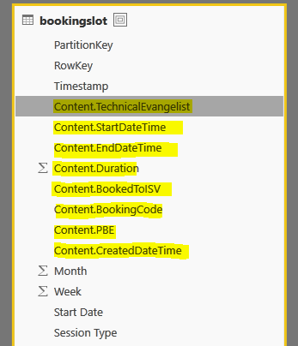

1. **Data Rationale:**

The fact that an ISV had a session is used to see which ISVs are engaged with the process, but for that we only need the name of the ISV and the session metadata (date, time TE. Etc – see the Schema).

To inform the user of their session, we need to transfer their name and email to outlook in Office365 to send the email with the calendar appointment.

1. **Data Removal:**

Use Azure Storage Explorer to remove the row from the isv or bookingslot tables and the entry will be auto-removed from all subsequent systems.

The auto-removal after the session executes, is applied in an Azure Function run on a timer that blanks that data out automatically.

1. **Other Descriptions:**

The contact data needs to be encrypted in Azure Table Storage for its limited lifetime when stored collectively in a table and the key will be stored in a KeyVault with limited access. The contact data is never decrypted and exposed through the UI in any manner.

This data will be decrypted when stored in a user calendar on a 1-by-1 basis.